Stażysta w dziale Supply Chain
Parker Hannifin Manufacturing Sp. z o.o.
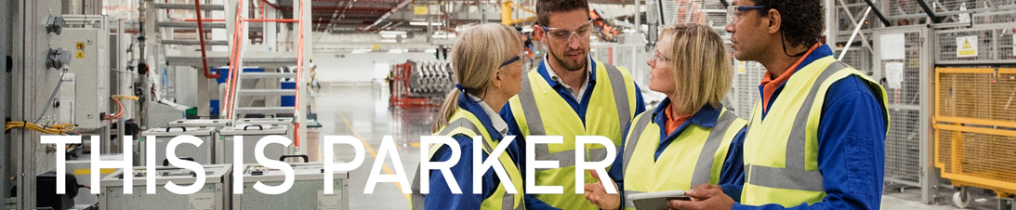

Parker Hannifin EMEA Sarl (PHEMEA), based in Etoy, Switzerland, is the Principal Operating Company for Parker in the EMEA region. It is supported by a network of Parker Manufacturing Divisions and Sales Company Entities. The Fluid Connectors Group Europe is a strategic business Group within PHEMEA. High Pressure Connectors Europe is a key service provider to the Fluid Connectors Group Europe

Lokalizacja:
Wroclaw ul. Stargardzka

Aplikacje wraz ze zgodą na przetwarzanie danych osobowych w procesie rekrutacji wyślij na mail:
Tomasz.potyrala@parker.com

Termin składania aplikacji:
15.08.2022

Parker jest pracodawcą zapewniającym równe szanse i nie dyskryminuje ze względu na wiek, rasę, religię, pochodzenie etniczne, płeć, orientację seksualną lub niepełnosprawność

Firma Parker jest zobowiązana do przestrzegania wszystkich obowiązujących przepisów ustawowych
i wykonawczych dotyczących gromadzenia, wykorzystywania, przekazywania
i przechowywania danych osobowych, w tym prawa Stanów Zjednoczonych, Unii Europejskiej (w tym rozporządzenia UE 2016/679 zwanego
„Ogólnym Rozporządzeniem o Ochronie Danych ”) oraz innych krajów,
w których firma Parker prowadzi swoją działalność.

www.parker.com

Parker Hannifin Manufacturing Cylinder and Accumulator Division Europe (CADE) produkuje chlodnice i akumulatory. Nasze produkty wykorzystywane są w układach hydraulicznych maszyn i pojazdów roboczych, np. ładowarkach, dźwigach.Obecnie zatrudnia około 50 pracowników.
Dział zarzadzania łancuchem dostaw i obsługi klienta zajmuje się obsluga zamowien do dostawców, planowaniem produkcji, logistyka wewnetrzna i obsluga klienta. wspiera wydziały produkcyjne i zajmuje się optymalizacją obecnych procesów produkcyjnych (skrawanie, montaż, pomocnicze), jak również wyborem, zakupem i wdrażaniem nowych maszyn i urządzeń.
Stażysta będzie raportować bezpośrednio do kierownika działu zarządzania łancuchem dostaw a do jego obowiązków będzie należało:

- Analizowanie stanów magazynowych
- Obliczanie potrzebnej powierzchni magazynowej
- Optymalizacja magazynu pod wzgledem ulozenia produktów
- Wdrażanie systemu skanowania na magazyn
- Wizualizacja potrzebnego czasu na przygotowanie zlecen produkcyjnych
- Optymalizacja procesu wysyłek import/ export

Od kandydatów oczekujemy:

- Wykształcenia wyższego technicznego lub w trakcie studiów
- Znajomości języka angielskiego
- Podstawowej znajomości narzędzi lean maufacturing
- Obslugi programu MS Excel
- Doswiadczenie w programie MRP mile widziane

Oferujemy:

- Zatrudnienie na 3-12 miesieczny staż w międzynarodowej firmie
- elastyczne godziny stażu
- rozwój osobisty, dużo praktyki a mało teorii
- stawka 18 zł / godzinę

Informujemy, że skontaktujemy się z wybranymi kandydatami.

